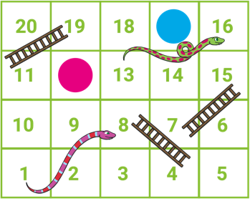




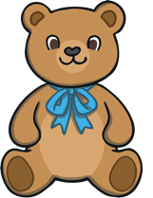


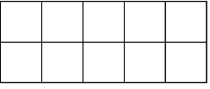
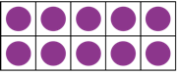
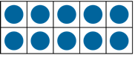

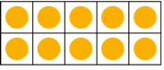






Spatial Reasoning
Spatial reasoning is about exploring shapes, arrangements and positional language.
match rotate
Baby Bear has found a shape tile. Can you see another tile of the same shape?

Baby Bear has used the shape tiles to make a picture. Talk about the shapes Baby Bear has used. Can you see any shapes that are the same? How are they the same? How are they different?

Counting Patterns Beyond 10
Looking at representations and numerals can help to practise counting beyond 10.
Look at these number cards. Talk about what you can see. Do you think the cards are in the correct order? What would you change to make the cards in number order? Why?
Two children are playing a game of Snakes and Ladders. Can you point to the numbers on the board and count from 1 to 20? Which numbers are the counters on? How do you know?
Building Numbers Beyond 10
11 12 13
Talk about these ten-frames. Can you spot the full frames of ten? What do you think 14 would look like?
The children have been collecting shells. What do you notice? How many shells did each child collect?
Baby Bear has made some lines of cubes. Talk about them– what do you notice? Can you find a line of 15 cubes?

Challenge Yourself:
- With a grown-up, play a counting game. One person starts counting and then the other person continues counting when the first person stops.
- Can you take turns and count all the way to 20?
- Can you count backwards too? Try starting at 20 and take turns to count down to zero.

Challenge Yourself:
- Draw two ten-frames on a sheet of paper. Place some small items, such as pom-poms, buttons, coins or washers into the ten-frames. How many did you find?
- Try again with a different set of items. Can you find enough items to fill both ten-frames? How many do you have now?

Challenge Yourself:
- Cut out some paper shapes and use them to make a picture. Ask a grown-up to make a picture too. Can you copy their picture using your paper shapes?
Maths Talk and Learn: Supporting White Rose Maths To 20 and Beyond
10
11
12
13
14
15
10
11
12
13
14
15

