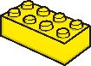

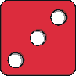
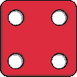

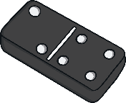
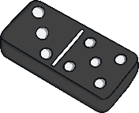




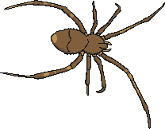
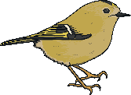







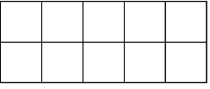



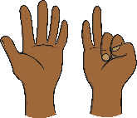
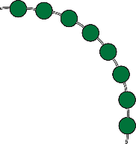

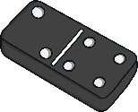
6

Combining Two Groups
Put two groups together to find out how many there are altogether.
How many spots are on each side of the domino? Try and recognise how many are in each group without counting them (subitising). Then, combine the two groups and find out how many spots each domino piece has altogether.
Which two dice could be put together to make 7?
Talk about what these part-whole models show. Which number is missing?

Maths Talk and Learn: Supporting White Rose Maths Growing 6, 7, 8

Challenge Yourself:
- Use both hands to grab a two handfuls of dried pasta. How many pieces are in each hand? Put the two handfuls together.
How many pasta pieces
are there in total?

Making Pairs
A pair is two.
Talk about how many pairs of legs each animal has.
Look at the quantities of fruit arranged into pairs. Some quantities have an odd one left that can’t be made into a pair. Is there a pattern of which numbers make even pairs and which don’t?

Composition of 6, 7, 8
6 7 8
six seven eight
Talk about which images show a representation of 6, 7 or 8.
Look at how these counters have been arranged on the ten-frames. How many counters are in each ten-frame? How do you know? What are the similarities and differences between them?

Challenge Yourself:
- Find toys or items around the room to place into pairs. Do all the toys have a partner, or are there any odd ones left over that don’t make a pair? Can you make pairs with 7 toys? Predict the answer and then check.
- Play a game which involves matching pairs of cards together or helping to match socks from the laundry.

Challenge Yourself:
- Count 7 bricks or beads into a container so that they cannot be seen. Then add one more brick/bead. Can you work out how many there are without counting them all? Take one or two items out of the container. How many are there now?
- How many different ways can you find to make 6, 7 and 8? How will you record this?

Time
now before later soon after then next
Talk about and describe the order of these events in your daily routine.
yesterday today tomorrow
Monday Tuesday Wednesday Thursday Friday Saturday Sunday
Talk about some regular events that
happen on certain days of the week.
Some things take a long time and some things take a short time. Compare the time it takes for these events to happen. Which takes the longest and which takes the shortest amount of time?
Time can be measured in lots of different ways and there are lots of different periods of time. Set a timer and see how many of each task you can do in one minute.
star jumps drawing self portraits build a tower of 10 bricks

Length and Height
long longer than longest short shorter than shortest
Compare the length of these pieces of ribbon.
tall taller than tallest short shorter than shortest
Look at the number of cubes used to
measure the height of the flowers.
Which flower is the tallest? How do
you know?
thick thin wide narrow near far

Maths Talk and Learn: Supporting White Rose Maths Growing 6, 7, 8

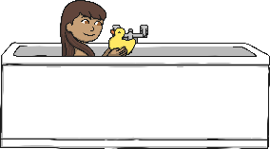


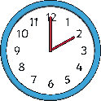

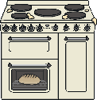
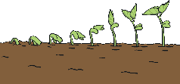


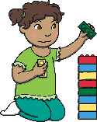
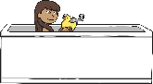










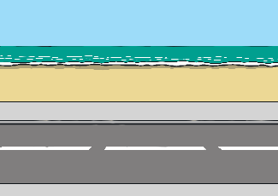
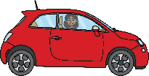
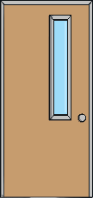

Challenge Yourself:
- Look back at some photos of yourself and your family taken recently and several years ago. Talk about how you have changed and when these events took place. What are you looking forward to in the future?

Challenge Yourself:
- Use measuring tools, such as a ruler, tape measure, or height chart to measure and compare the length or height of items belonging to different family members.
- Throw a screwed-up ball of paper across the room. Count how many steps it takes you to reach the ball. Repeat this and then compare whether you threw your ball of paper nearer or further.

