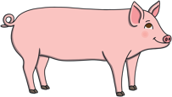
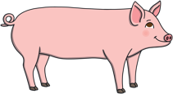
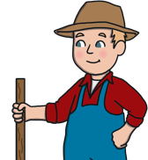
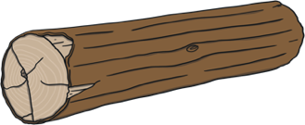




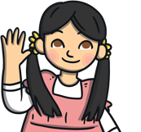
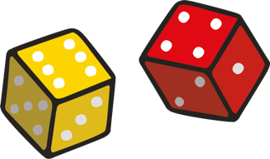

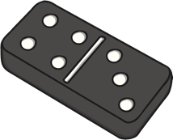
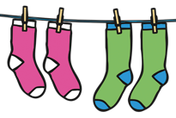
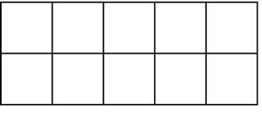

Sharing and Grouping
share fair equal groups same
Are these equal groups? How would you move the frogs to make the
groups equal?
The farmer would like to fairly share his pigs between the two pens. Talk about how the farmer could put the pigs into the pens. What did you find out?
What groups can you see on the beaded necklaces? How are the necklaces similar? How are they different?

Doubling
Double means ‘twice as many’ or ‘two of the same’.
doubles non-doubles pairs
Which of these ten-frames are showing doubles? How do you know?
I am painting a ladybird that shows a double. So
far, my ladybird has 3 spots on one side. When
I've finished, how many spots will there be all
together?

Challenge Yourself:
- Ask an adult to get you 5 biscuits and 2 plates. Share the biscuits equally between the two plates. What happens? How could you solve this problem so that it is still fair?

Challenge Yourself:
- Play a doubles game with 2 dice. Can you roll a double? What doubles can you find? Can you turn the dice to show double 5?
Maths Talk and Learn: Supporting White Rose Maths Find My Pattern
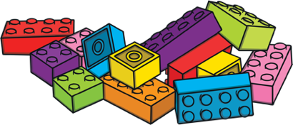



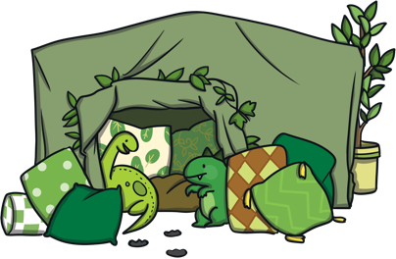
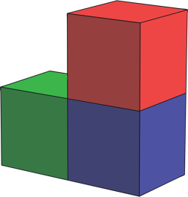
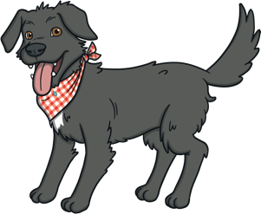
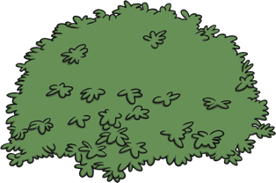


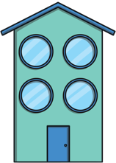

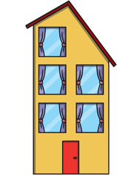






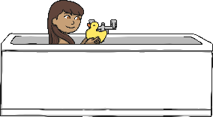
Spatial Reasoning: Visualise and Build
next to in under on behind in front of
Talk about what you can see in the picture of Herbie the dog. Where is the bone? What is in front of the bowl? Try to use some of the words above.
Use some small world toys to make a scene
from one of your favourite story books. Can you
tell your grown up where you have placed the
different characters and objects?
Your friend wants to build a model like this one.
Pretend you’re on the telephone and give them
instructions for how to build it. What colour bricks
will they need? Where will they need to put them?

Even and Odd
Even numbers can be shared equally into two groups.
Odd numbers can’t be shared equally into two groups - there will always be one left over.
even odd
Tania has sorted the number shapes into odd and even. Has she done it correctly? Why / why not?
even odd

Which of these houses have an odd number of windows? How do you know?

Maths Talk and Learn: Supporting White Rose Maths Find My Pattern

Challenge Yourself:
- Ask an adult to build a simple model using 5 blocks, but they must keep it hidden from you. Ask them to describe what their model looks like and where the different blocks are. Can you listen carefully and build the model? When you have finished, look at your adult’s model. Does yours look the same?

Challenge Yourself:
- Take a handful of building bricks. Sort them into groups of the same colour. Now look at each of the groups. Which group has an even amount of bricks? Which group has an odd amount? How can you check?

